### A PROJECT REPORT

### ON

“REVO - CLINIC MANAGEMENT SYSTEM”

SUBMITTED BY

|  |  |  |  |
| --- | --- | --- | --- |
|  | **Name** | **Univ. Roll No.** |  |
|  | AVIJEET GORAI | 32201220060 |  |
|  | SAIKAT MONDAL | 32201220051 |  |
|  | SARBAJIT BANERJEE | 32201220052 |  |
|  | SUMIT MAHATO | 32201220083 |  |
|  | AKSHAY CHATTERJEE | 32201220091 |  |

UNDER THE GUIDANCE OF

**MR. Sujoy Kumar Basu**

*(Assistant Professor)*

Computer Applications

**Asansol Engineering College**

ASANSOL

Affiliated to

MAULANA ABUL KALAM AZAD UNIVERSITY OF TECHNOLOGY

*MAY 2023*

# DECLARATION

We being the students of BCA, 3rd Year; 6TH semester of **ASANSOL ENGINEERING COLLEGE** hereby declares that the project report of MERN Stack under title “**REVO** **CLINIC MANAGEMENT SYSTEM**” is our work. All care has been taken to keep this report free and we sincerely regret for any unintended discrepancies that might have crept into this report. We shall be highly obliged if errors be brought in our attention.

THANK YOU

|  |  |
| --- | --- |
| AVIJEET GORAI | 32201220060 |
| SAIKAT MONDAL | 32201220051 |
| SARBAJIT BANERJEE | 32201220052 |
| SUMIT MAHATO | 32201220083 |
| AKSHAY CHATTERJEE | 32201220091 |

**TABLE OF CONTENT**

TITLE PAGE NO

ACKNOWLEDGEMENT 5

INTRODUCTION 6

OBJECTIVE 8

PROJECT WORKFLOW 9

MODULES AND FUNCTIONALITY 10

SOFTWARE AND HARDWARE REQUIREMENT 11

DATABASE INFORMATION 12

PROJECT SCREENSHOT 13

TESTING 18

FUTURE SCOPE 19

REFERENCES 20

ACKNOWLEDGEMENT

It is our great privilege to express profound and sincere gratitude to our Project Supervisor, **Sujoy Kumar Basu, Asistant Professor** for providing us with very cooperative and precious guidance at every stage of the present project work being carried out under his supervision. His valuable advice and instructions in carrying out the present study has been a very rewarding and pleasurable experience that has greatly benefited us throughout the course of work.

We would like to convey our sincere gratitude towards **DR. PINTU PAL**, Head of the Department of Computer Application, Asansol Engineering College for providing us the requisite support for time completion of our work. We would also like to pay our heartiest thanks and gratitude to all the teachers of the Department of Computer Application, Asansol Engineering College for various suggestions being provided in attaining success in our work.

We would like to express our earnest thanks to our other colleagues along with all technical staff of the Department of Computer Application, Asansol Engineering College for their valuable assistance being provided during our project work.

Finally, we would like to express our deep sense of gratitude to our parents for their constant motivation and support throughout our work.

AVIJEET GORAI

SAIKAT MONDAL

SARBOJIT BANERJEE

AKSHAY CHATTERJEE

SUMIT MAHATO

**Date: 26-05-2023 3rd Year**

**Place: Asansol Computer Application**

# INTRODUCTION

Nowadays many systems have been developed to make life easier. The system will include database that will record all the data. For the private hospital, usually they are using digital system to record the patient information and other information that related to the hospital. There are many systems for clinic management system, but it does not meet the local user requirement that is still new in the electronic system. Here, it will be more explanation of the system.

**Revo Clinic** is developed to improve the clinic management and automates the workflow that happens in the clinic. This system is considering all the activities in the clinic. Patient will make registration first. If the patient never registered before, patient information collected and stored in the database. However, if it is an existing patient the patient data is search-using IC (identification card) no. This will improve the record of the patient and save the time during the registration. At this time, patient is assign to the doctor Once the patient gets the treatment, the doctor will send the report including the medicine name. The staff will view the report and complete the patient record. After that, the staff will prepare the bills for the patient. The patient can choose mode to pay cash or maybe the clinic is panel doctor for the patient. Then the staff will update the medicine stock and the patient record will be kept in database. 2 The clinic management system is very beneficial for a clinic/doctor. It will stores complete patient record. The most important thing is it will make it easier for the retrieval of history information of the patient. In case, if patient is allergic for certain medicine, the doctor may detect what type of medicine. For the security, before the user enters the system they have to input their username and password before log in to the system. The system has different access for the difference user. For the management of the clinic, they may view the daily report of clinic.

# Basic Tools Used

MERN: A stack composed of MongoDB, Express.js, React, and Node.js, commonly used for building full-stack web applications with JavaScript.

React: A JavaScript library for building user interfaces, known for its component-based architecture and efficient rendering, making it popular for single-page applications.

CSS: Cascading Style Sheets, a stylesheet language used to describe the look and formatting of a document written in HTML, allowing developers to control the visual presentation of web pages.

Node.js: A runtime environment for executing JavaScript code on the server-side, enabling the development of scalable and high-performance network applications.

REST API: Representational State Transfer Application Programming Interface, a software architectural style used for designing networked applications that communicate over HTTP by leveraging standard CRUD (Create, Read, Update, Delete) operations.

# OBJECTIVE

The main objective of developing the MERN training project was to fulfill the requirements for the training. From a technical perspective, the project aimed to improve the record-keeping process for patients, doctors, and medicine, making it easier for individuals to book appointments from the comfort of their homes. This would help reduce the number of lost records and improve data retrieval for the staff of the clinic. Additionally, the system aimed to record all the profiles of doctors in case the clinic has more than one doctor.

The inventory module for medicine was another important feature, allowing the clinic to check the balance of medicine and the information related to medicine such as the manufacturer and price. The system would also display when medicine was running out of stock.

The system would make it easier for management to view the payment record for the clinic and generate reports on the operation of the clinic. For example, reports could be generated about the number of patients per day and the total income for the clinic per day. Overall, the system aimed to streamline processes, reduce errors, and improve the overall management of the clinic.

# PROJECT WORKFLOW :-

## REVO CLINIC

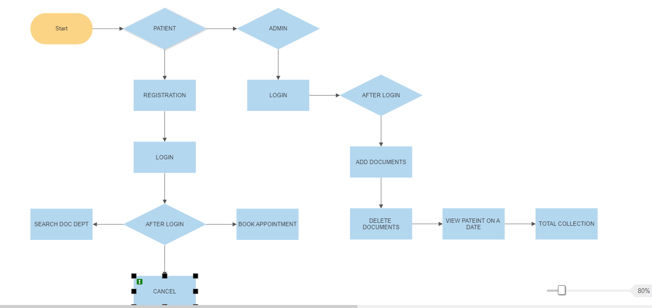

This is a MERN Stack project based on the workflow of MongoDB, Express, React, and Node.js. Patients can register, log in, search for a doctor, book an appointment, and complete the process. Admins can log in, access the Express-based admin dashboard, manage doctors, and view patient appointment details. The data is stored in a MongoDB database, accessed through Node.js, and the user interface is built using React.

# MODULES AND FUNCTIONALITY

The system consists of two modules, namely the Admin module and the User module. The Admin module is designed for the owner of the shop or clinic, who is responsible for managing all the patients who have booked appointments with the doctors. The Admin module has a login feature that requires a unique username and password to gain access to the dashboard. Once the admin is logged in, he/she can manage the doctors by adding or deleting them from the clinic. This feature allows the admin to have full control over the doctors working in the clinic.

On the other hand, the User module is designed for patients who want to register and book appointments with the doctors. The registration process involves creating a user account by providing basic personal information such as name, email, phone number, and address. Once the user is registered, he/she can log in to the website using their credentials.

After logging in, the user can browse through the list of doctors available on the website and select their preferred doctor. The user can also check the availability of the doctor and book an appointment using a registration or booking form. The booking form allows the user to provide details such as the date and time of the appointment, the reason for the visit, and any other relevant information. All the appointment details are stored in the database, which can be accessed by the admin to manage the appointments and monitor the activity in the clinic.

In summary, the system provides a convenient way for patients to book appointments with doctors and for the clinic owner to manage the doctors and appointments efficiently. The Admin module allows the owner to have full control over the clinic, while the User module provides a user-friendly interface for patients to access the system.

# SOFTWARE AND HARDWARE REQUIREMENTS

Hardware:-

PROCESSOR :- Intel i3 or i5 1.8GHz.

MOTHERBOARD :- According to the processor requirement

RAM :- 8GB

FREE DISK SPACE :-300MB

Software:-

Ui Development – React 18.x, ES 6, HTML 5, CSS.

Frontend To Backend Communication – REST API

Backend – NodeJS

Server – Express JS

Database – MongoDB

Node JS – MongoDB connection using Mongoose

IDE USED – VS Code

# DATABASE INFORMATION

This MERN Stack project uses MongoDB as its database. The data is stored in a single object that can be accessed by the admin to manage the information related to the project. The admin can view the details of patients who have booked appointments with the doctor, including their name, contact information, the doctor they have booked an appointment with, and the date and time of the appointment. Additionally, the admin can see the total number of patients who have booked appointments.

The database is divided into three collections: book collections, doc collections, and emp collections. The book collection stores the details of the appointments made by patients. Each entry in this collection contains information such as the name of the patient, the doctor they have booked an appointment with, the date and time of the appointment, and the contact details of the patient.

The doc collection stores the details of the doctors added to the system. The admin can add new doctors or delete existing ones from this collection directly. Each entry in this collection contains information such as the name of the doctor, their specialty, contact information, and other relevant details.

The emp collection stores the details of the registered users who have created an account on the website. Each entry in this collection contains information such as the name of the user, their contact information, and their login credentials.

In summary, this MERN Stack project uses MongoDB as its database, with three collections to store information related to patients, doctors, and registered users. The admin can manage the data within the database by adding or deleting doctors and viewing appointment details.

# PROJECT SCREENSHOT

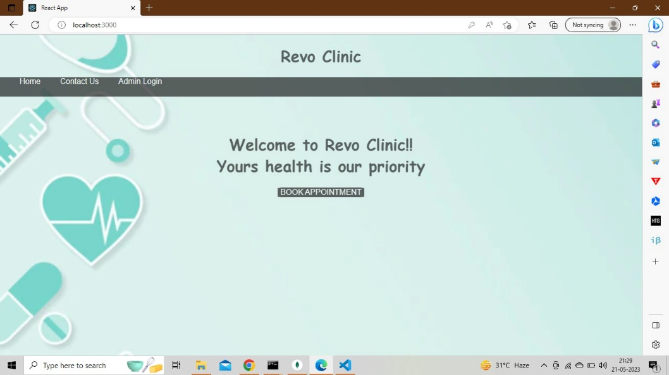

HOME PAGE OF THE CLINIC

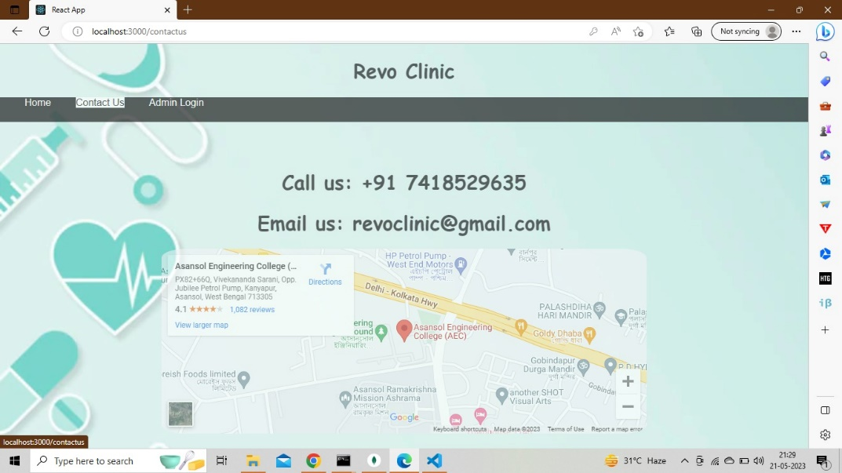

CONTACT US PAGE OF THE CLINIC

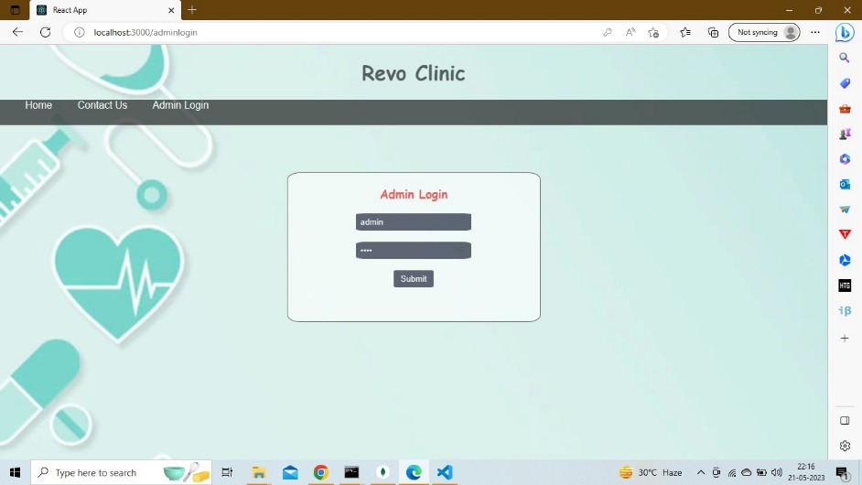

ADMIN LOGIN PAGE FOR LOGING IN TO THE ADMIN PAGE

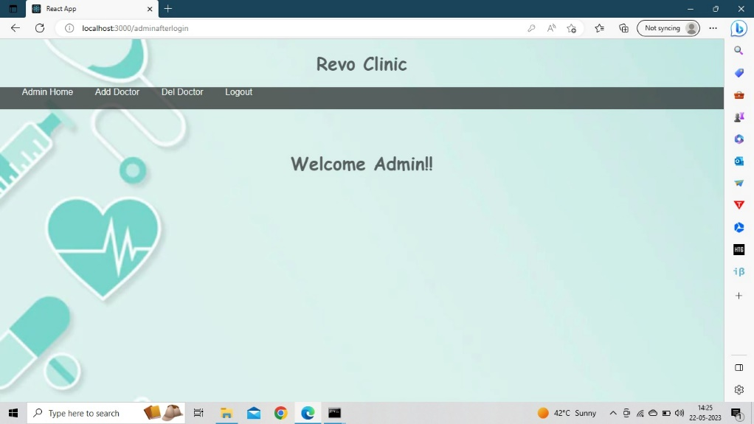

ADMIN AFTER LOGIN HOME PAGE

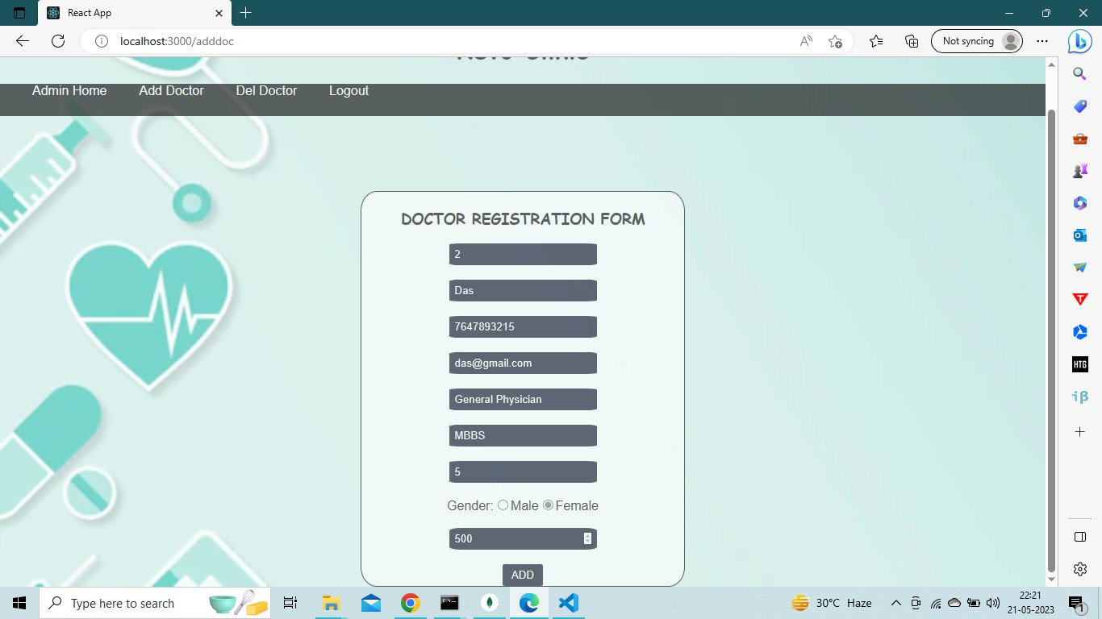

DOCTOR REGISTRATION PAGE FOR ADMIN TO ADD DOCTORS

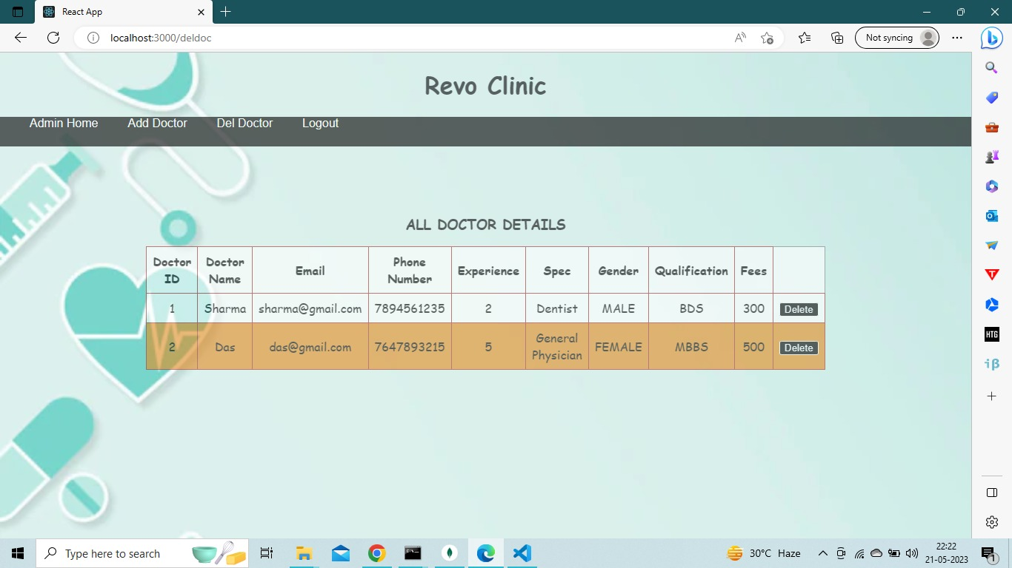

DOCTOR DETAIL’S VIEW/ DELETE BY ADMIN

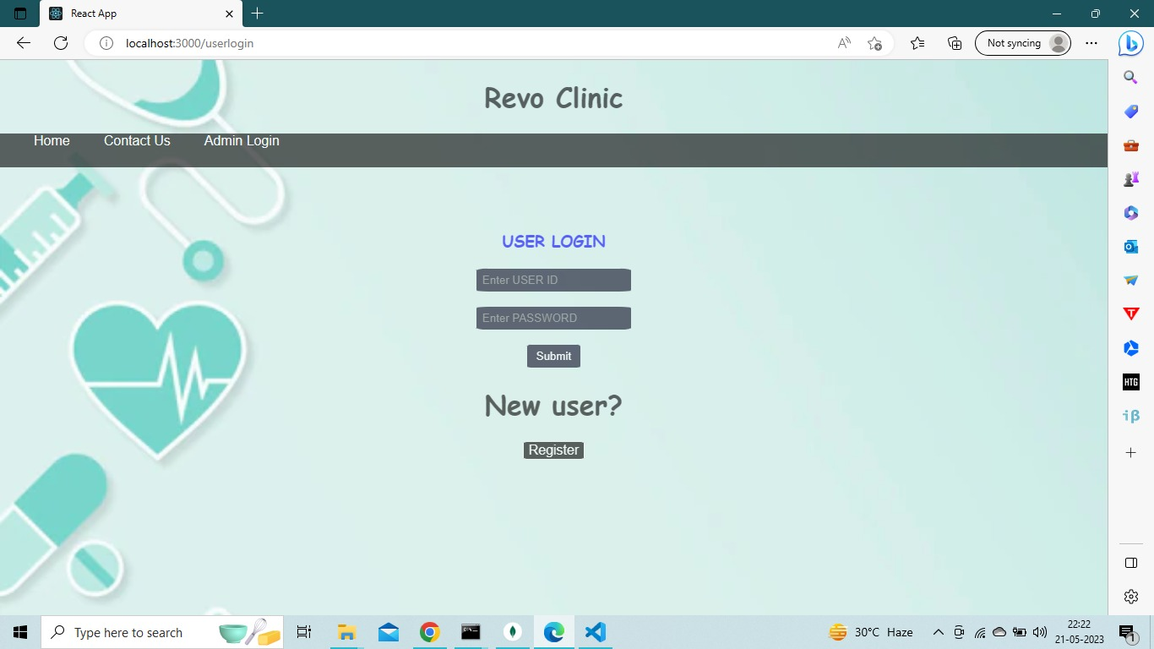

USER LOGIN PAGE FOR EXISTING/ NEW USER(PATIENT)

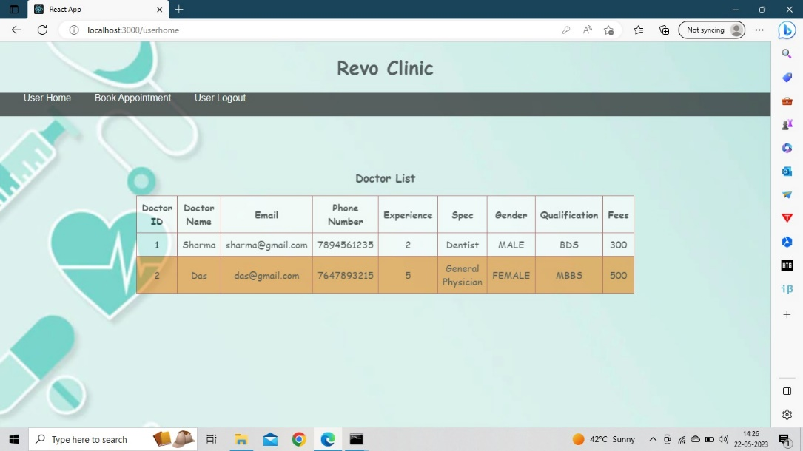

DOCTOR DETAILS PAGE AFTER USER(PATIENT) LOGIN

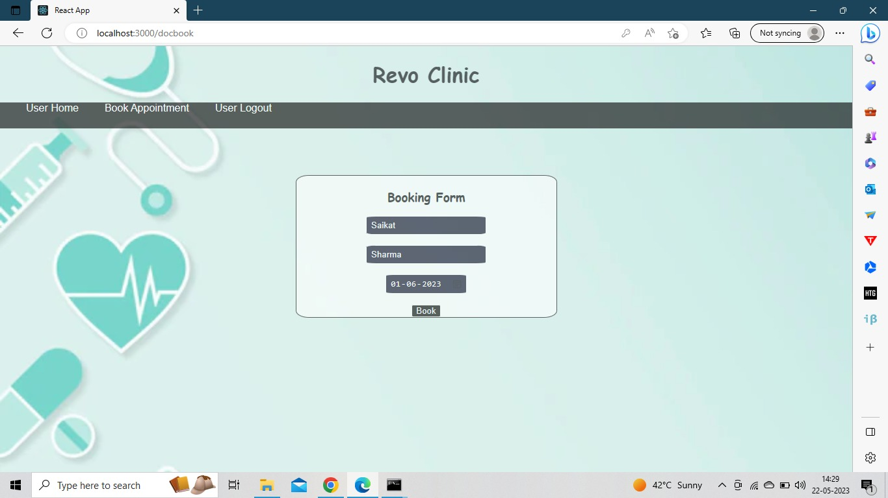

BOOK APPOINTMENT PAGE FOR USER (PATIENT)

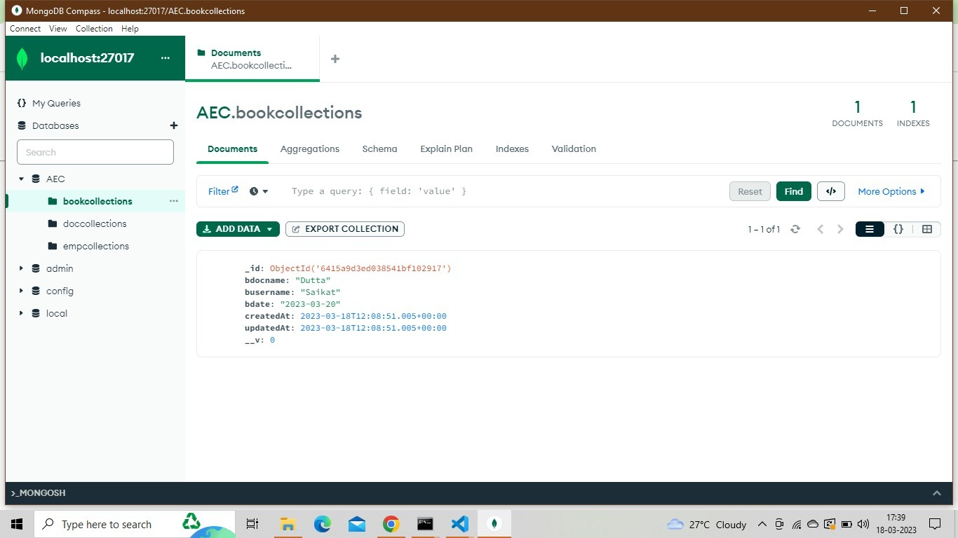

DATABASE SHOWING THE BOOKIMG DETAILS OF USERS (PATIENTS)

DATABASE SHOWING THE DOCTOR DETAILS, REGISTERED BY THE ADMIN

DATABASE SHOWING THE DOCTOR BOOKIMG DETAILS OF USERS (PATIENTS)

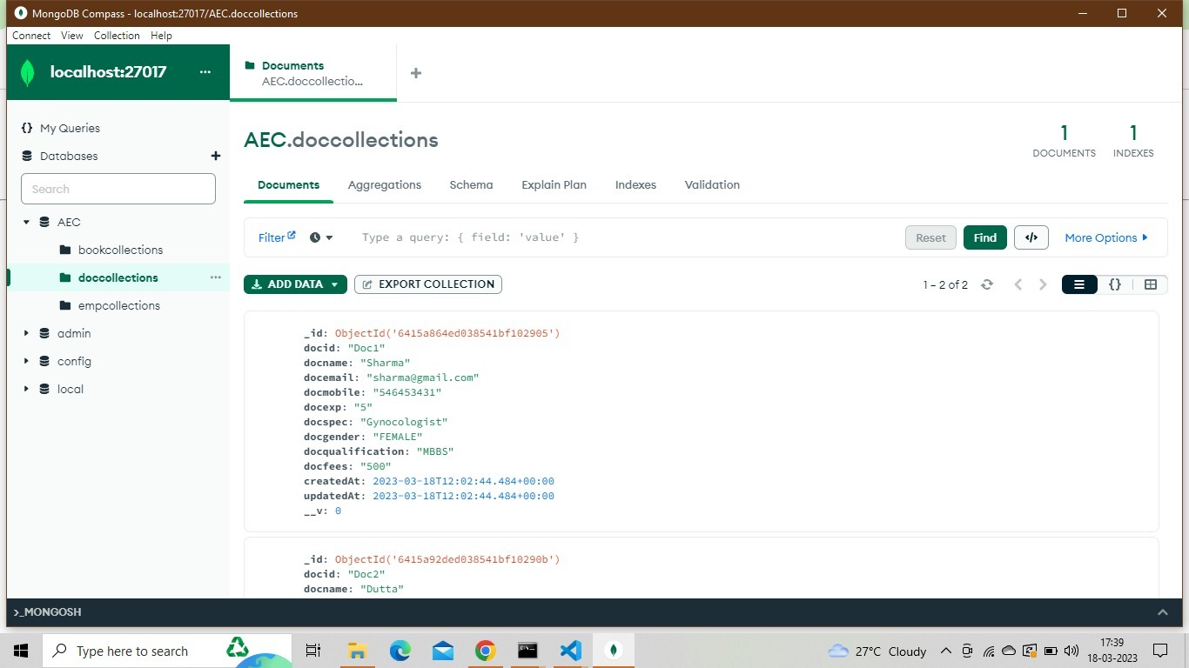

DATABASE SHOWING THE DOCTOR DETAILS FOR ADMIN

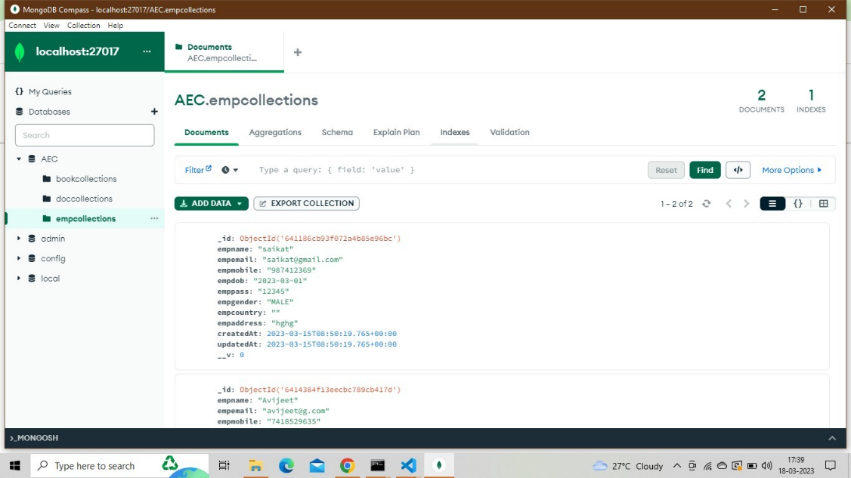

­­­­­­­­

DATABASE SHOWING THE REGISTRATION DETAILS OF USERS (PATIENTS)

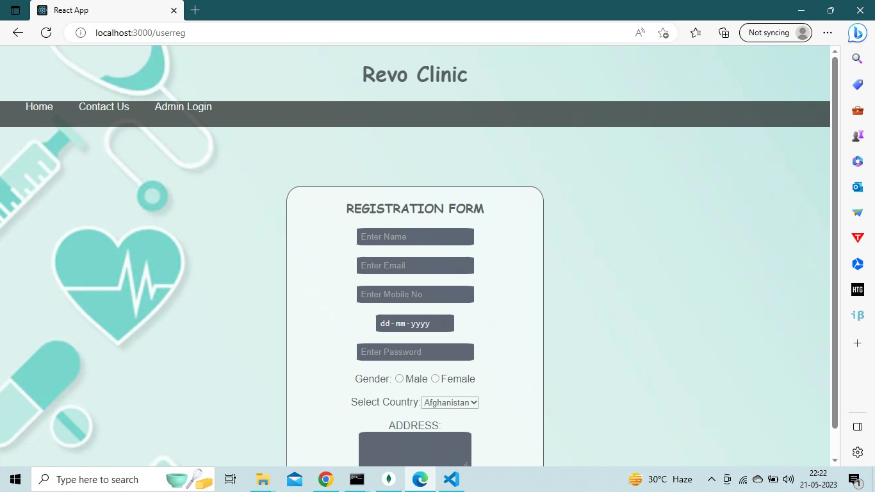

USER(PATIENT) REGISTRATION FORM PAGE FOR NEW USER (PATIENT)

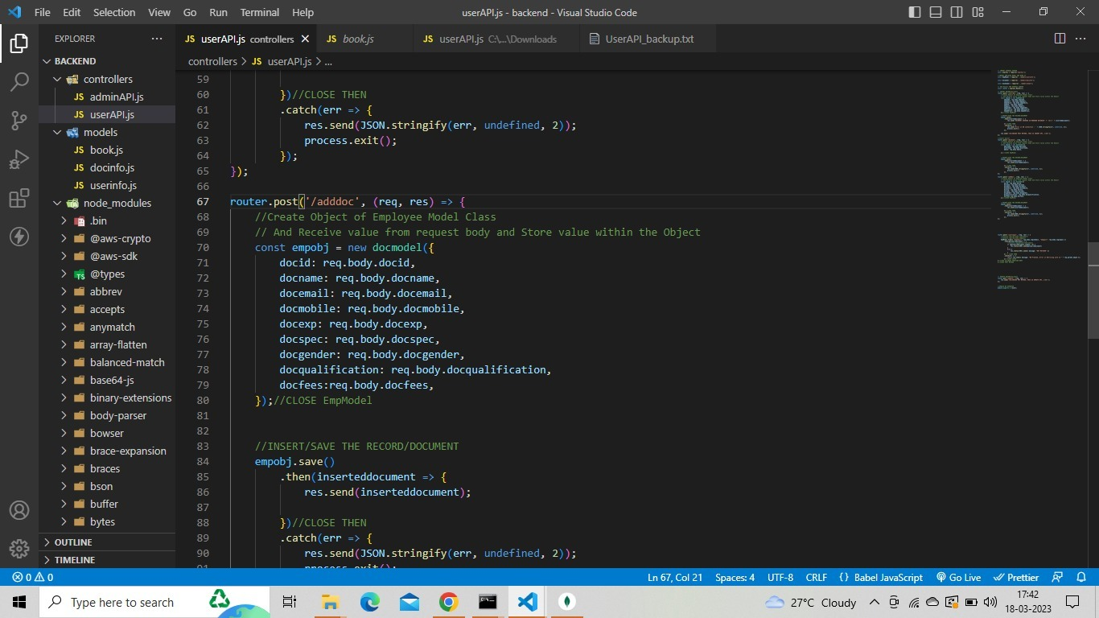

SHOWING THE USER API CODE FROM BACKEND

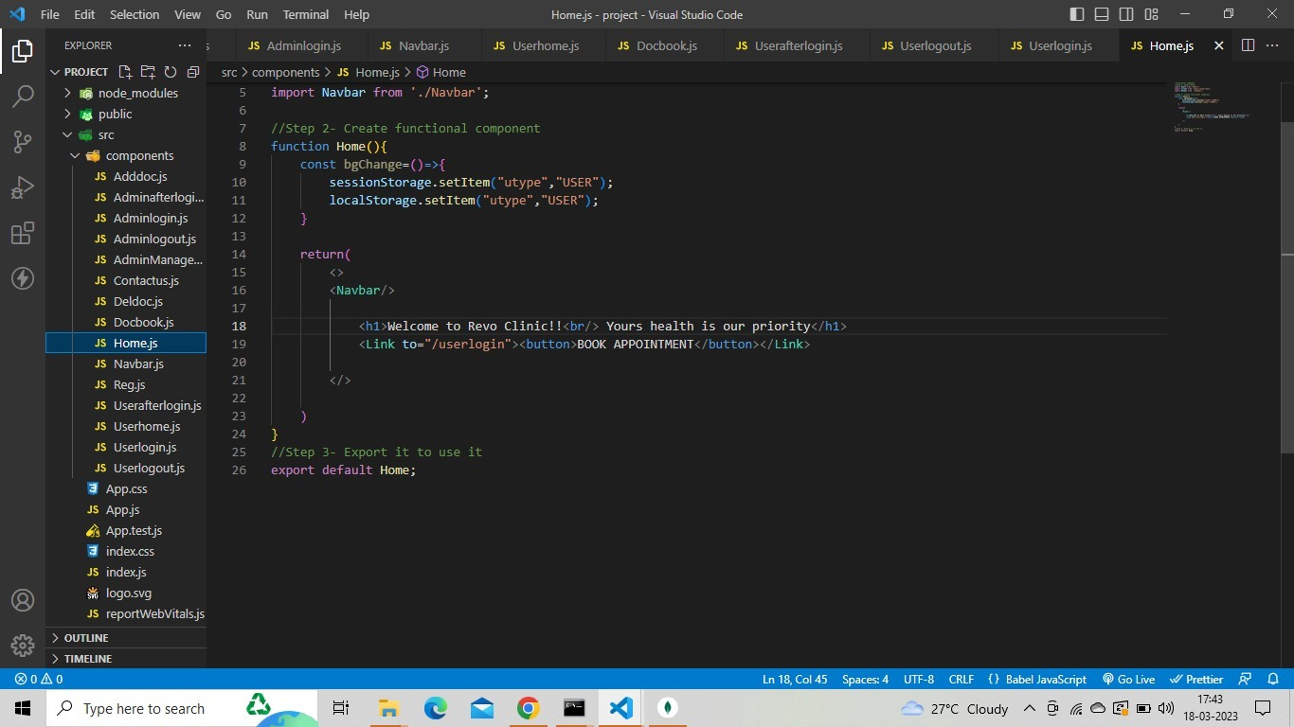

SHOWING THE HOME PAGE CODE FROM FRONTEND

# TESTING

# The purpose of this testing note is to report on the testing of the MERN Stack Clinic Management System. This report covers the testing of website functionality, security, performance, and scalability.

# Functionality Testing:

# During our testing, we ensured that all the features and functions of the website are working correctly. We tested the ability to login users and admins, create profiles, and book doctors. We also tested the ability to search for doctors and delete them. We verified that the user interface is easy to use and that all the pages load properly.

# Security Testing:

# We conducted a thorough security check of the website to ensure that user passwords are encrypted and stored securely. We also tested that user accounts are protected against brute force attacks. We verified that the application is protected against cross-site scripting and SQL injection attacks. We tested that the application is protected against denial of service attacks. We also verified that user accounts are protected against unauthorized access.

# Performance Testing:

# We measured the website response time and page load times to ensure that the website is performing efficiently. We also tested the website scalability by increasing the number of users and doctors to ensure that the website can handle large amounts of traffic.

# **Conclusion:**

# Overall, we found the MERN Stack Clinic Management System to be functioning properly and securely. We recommend implementing the necessary changes to improve website performance and scalability.

# FUTURE SCOPE

The MERN Stack project has great potential for future expansion and development. Here are some possible future scope ideas:

* **Adding new features:** The project can be expanded by adding new features, such as an online forum where students can discuss their queries, a chatbot that can answer common questions, or a virtual classroom with live video streaming and whiteboard capabilities.
* **Mobile app development:** To reach a wider audience, the project can be converted into a mobile app that can be downloaded from app stores.
* **Integration with social media:** The project can be integrated with popular social media platforms, such as Facebook, Twitter, and Instagram, to reach a wider audience and allow users to share their progress and achievements.
* **Gamification:** To make the learning experience more engaging and fun, the project can be gamified with features such as badges, leaderboards, and rewards.
* **Personalized learning:** The project can be enhanced with machine learning algorithms that can personalize the learning experience for each user based on their learning preferences, pace, and style.

In conclusion, the MERN Stack project has a promising future with endless possibilities for expansion and development. With the addition of new features, mobile app development, social media integration, gamification, and personalized learning, the project can become a valuable resource for students and teachers alike. The project team is grateful for the opportunity to work on this project and looks forward to further developments in the future.

# REFERENCES

**Online**

* <https://www.w3schools.com/>
* <https://www.tutorialspoint.com/index.htm>
* <https://en.wikipedia.org/wiki/CSS>
* [www.google.com](http://www.google.com/)
* [www.youtube.com](http://www.youtube.com/)

#### Offline

* + Internet Technology and Web Design -By Dr. R. k. Jain
  + Internet And Web Technology -By A Ravichandran

The project was successfully completed with the help of our mentor, Mr. Sujoy Kumar Basu who shared their knowledge and expertise. We are grateful for the support, hard work, guidance, and teamwork that made the project a success. We hope that everyone will appreciate and benefit from our project.

THANK YOU